

**WEB TECHNOLOGY LAB**

By

P Lakshmi sri charitha(1641033)

Under the guidance of

Ms. Anita HB

Web Technology Lab record submitted in partial fulfillment of the requirements of IV semester BCA,

Christ (Deemed to be University)



CERTIFICATE

*This is to certify that the* ***Web Technology lab*** *record of work done by* ***Lakshmi sri charitha (1641033)*** *of Christ (Deemed to be University), Bangalore, in partial fulfillment of the requirements of IV Semester BCA during the year 2018.*

**Head of the Department Project Guide**

Valued-by:

|  |  |  |  |
| --- | --- | --- | --- |
|  |  | Name | : Lakshmi sri charitha p |
| 1. |  | Register Number | : 1641033 |
|  |  | Examination Centre | : Christ University |
| 2. |  | Date of Exam | : 10/04/2018 |

1. **Create a HTML page that will have the following: Headers, Linking and Images**

**Code:**

**Homepage:**

<html>

<head>

<style>

body

{

background-repeat:no-repeat;

background-size:cover;

}

h1

{

color:red;

}

ul

{

color:#18e06b;

}

</style>

</head>

<body bgcolor = "grey">

<table style="width:100%">

<tr>

<p>

<font color = "red">

<td><h3 align="center"><b>ABOUT US</b></a></h3></td>

<td><h3 align="center"><b>PATIENT CARE</b></a></h3></td>

<td><h3 align="center"><b>CENTRES OF EXCELLENCE</b></h3></td>

<td><h3 align="center"><b>LOCATIONS</b></a></h3></td>

<td><h3 align="center"><b>CONTACT</b></h3></td>

</font></p>

</tr>

<tr>

<td><a href= "formating.html"> <img src="C:\Users\Admin\Desktop\Web technology\gg.jpg" width="300" height="200" hspace="20"></a></td>

<td><a href="Patient care.html"><img src="C:\Users\Admin\Desktop\Web technology\heart.png" width="200" height="200"></a></td>

<td><a href = "center of excellence.html"><img src="C:\Users\Admin\Desktop\Web technology\ad1.jpg" width="300" height="200"></a></td>

<td><img src="C:\Users\Admin\Desktop\Web technology\location.png" width="200" height="200"></a></td>

</tr>

</table>

<hr>

<a href="C:\xampp\htdocs\wtlab\form.php">Login</a>

</body>

</html>

**Output:**

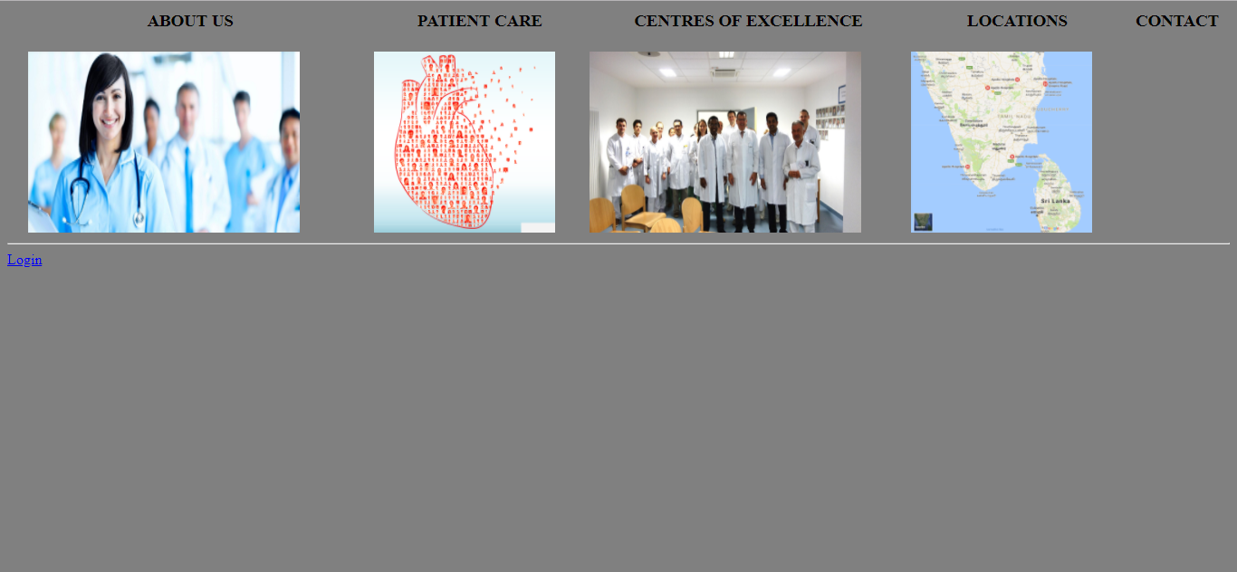

1. **Create a HTML page that will have the following: Frames, Unordered Lists, Nested and ordered Lists**

**Code:**

**frame.html**

<html>

<head>

<title> Frame </title>

</head>

<body bgcolor = "black">

<img src="C:\Users\Admin\Desktop\Web technology\s.png" width="70" height="100">

</body>

</html>



**frame_b.html**

<html>

<head><title> ordered list</title>

<style>

body

{

background-repeat:no-repeat;

background-size:cover;

}

</style>

</head>

<body background ="C:\Users\Admin\Desktop\Web technology\download.jpg">

<h1> patient details </h1>

<ul style="list-style-type:square">

<li>Patient Name </li>

<li>Apointment date</li>

<li>Gender </li>

<ol>

<li> male </li>

<li> female </li>

</ol>

<li>Patient address</li>

<li>Patient age</li>

</ul>

</body>

</html>

**OUTPUT:**

**3. Create a HTML page that will have the following: Tables and Formatting**

**Code:**

<html>

<head>

<title> Formating </title>

<style>

/*body

{

background-repeat:no-repeat;

background-size:cover;

}*/

body{

height: 200px;

background: red; /* For browsers that do not support gradients */

background: linear-gradient(to right, rgba(255,0,0,0), rgba(255,0,0,1)); /* Standard syntax (must be last) */

}

h1

{

text-shadow: 2px 2px white;

}

.cha

{

float : right;

}

</style>

</head>

<body background ="C:\Users\Admin\Desktop\Web technology\download.jpg">

<h1 align="center"> <b> About Apollo hospital </b> </align></h1>

<hr>

<p> <i><font size ="4" color = "black"> Apollo Hospitals Enterprise Limited is an Indian hospital chain based in Chennai, India.

It was founded by Dr Prathap C. Reddy in 1983. Several of the group's hospitals have been among

the first in India to receive international healthcare accreditation by America-based <b>Joint Commission International (JCI)</b> .

<del>[2][3]</del> as well as 13 NABH National Accreditation Board for Hospitals & Healthcare Providers hospitals.[4]

<br>

The group has developed services in telemedicine, after starting a pilot project in 2000 in Pratap Reddy's home village.

Apollo Hospitals was established in 1983 by Dr. Prathap C Reddy. It was India’s first corporate hospital, and is acclaimed

for pioneering the private healthcare revolution in the country. Since then, Apollo has risen to a position of leadership

and has emerged as Asia’s foremost integrated healthcare services provider. It has a robust presence across the healthcare

ecosystem, including Hospitals, Pharmacies, Primary Care & Diagnostic Clinics. The Group also has Telemedicine units across 10 countries,

Health Insurance Services, Global Projects Consultancy, Medical Colleges, Medvarsity for E-Learning,

Colleges of Nursing and Hospital Management and a Research Foundation. In addition, 'ASK Apollo' - an online consultation portal

and Apollo Home Health provide the care continuum.

<br>

The cornerstones of Apollo's legacy are its unstinting focus on clinical excellence, affordable costs, technology and forward-looking

research & academics. Apollo Hospitals was among the first few hospitals in the world to leverage technology to facilitate seamless

healthcare delivery through electronic medical records, hospital information systems and telemedicine-based outreach initiatives.

The organization embraced rapid advancement in medical equipments worldwide, and pioneered the introduction of several cutting edge

innovations in India. Soon the country's first-ever Proton Treatment Cancer Centre will be launched by Apollo, and it will serve

over 3 billion people.

<br>

Since inception, Apollo Hospitals has been honored by the trust of over 50 million patients from 140 countries.

At the core of Apollo's patient-centric culture is TLC (Tender Loving Care), the magic that inspires hope amongst its patients.

<br>

<hr>

<b><mark><U>Company Vision</U></mark></b>

<br>

Apollo's vision for the next phase of development is to 'Touch a Billion Lives'.

<hr>

<b><mark><U>Mission Statement</U></mark></b>

<br>

"Our mission is to bring healthcare of International standards within the reach of every individual. We are committed to the achievement

and maintenance of excellence in education, research and healthcare for the benefit of humanity"

<hr>

Apollo Hospitals has always championed social initiatives that transcend social and income barriers. Notable ventures introduced by the

organization are Save a Child's Heart Initiative (SACHi) which provides quality paediatric cardiac care to children from underprivileged

sections of society. <b>SAHI (Society to Aid the Hearing Impaired)</b> and the CURE Foundation focused on cancer care assist children from

financially challenged homes. Envisioned by Dr. Reddy, to introduce population health into the Indian narrative, the Total Health

Foundation is piloting a unique model of healthcare in the Thavanampalle Mandal of Andhra Pradesh. It aims to provide

"holistic healthcare" for the entire community starting from birth, through one's journey into childhood, adolescence, adulthood

and old age.

<br>

In a rare honour, the Government of India issued a commemorative stamp in recognition of Apollo's widespread contributions,

the first for a healthcare organization. <i><b>Dr. Prathap C Reddy</b></i>, Founder Chairman of the Apollo Hospitals Group has been conferred

with the prestigious Padma Vibhushan, India's second highest civilian award.</i></font>

<del><sub>[5]juice</sub>ihjihfiue</del>

<del><sup>rfewfw</sup>dvfrf</del>

</p>

<hr></hr>

</p>

<div class="cha">

<img src="founder.jpg">

</div>

<h3><b><mark> <font size = "5">Founder </mark></b></h3>

<table border = "2">

<tr>

<th> <i><b><font size ="4" color="red">Founder</font></b></i></th>

<th> <i><b><font size ="4"color="red">Awards</font></b></i></th>

<th> <i><b><font size ="4"color="red">Eduction</font></b></i> </th>

</tr>

<tr>

<td> <font size ="3" >Prathap.C.Reddy</font></td>

<td> <font size ="3">padma vibhusan,padma bhusan</font></td>

<td> <font size ="3">Stanley Medical College</font></td>

</tr>

</font>

</table>

</body>

</html>

**Output:**

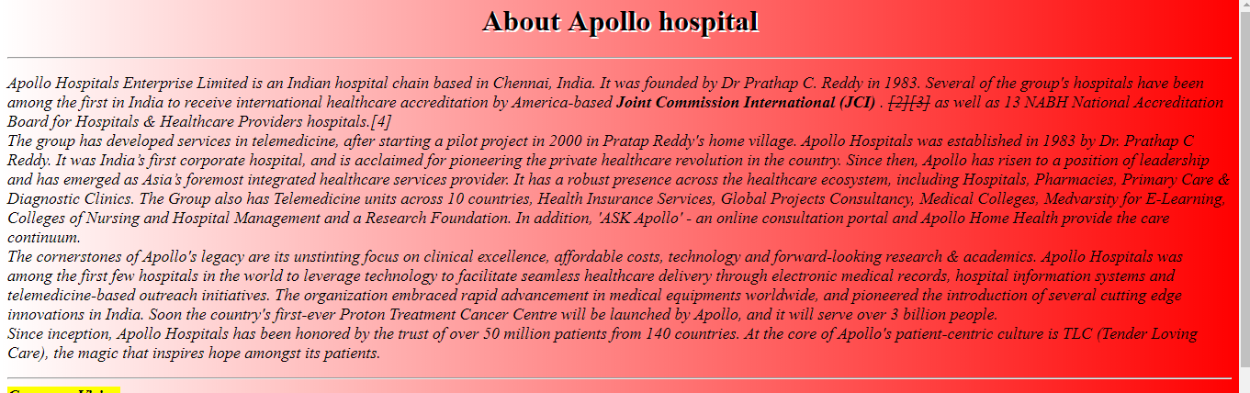

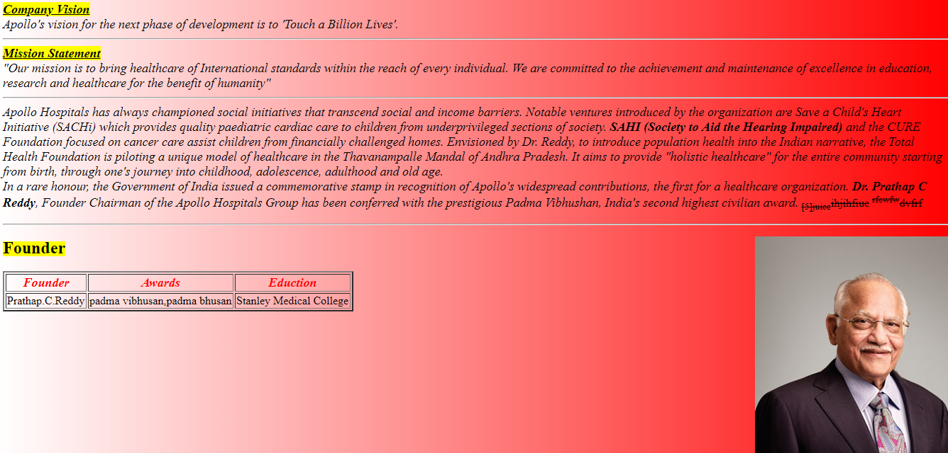

**4 Create a HTML page that will have the following: Forms, Creating and Using Image Maps, Tags**

<html>

<head>

<title> MAPPING </title>

<style>

p

{

padding: 20px;

}

</style>

</head>

<body bgcolor="grey">

<p>

This is my &nbsp; &nbsp;image mapping for <br> <b>&hearts; center of excellence <br> &hearts; to find a doctor <br> &hearts; patient care</b></p>

<img src = "pc2.png" usemap="=#map">

<map name = "map">

<area alt="" title="center of excellence" href="C:\Users\Admin\Desktop\Web technology\center of excellence.html" shape="rect" coords="7,126,38,133" />

<area alt="" title="find a doctor" href="C:\Users\Admin\Desktop\Web technology\find.html" shape="poly" coords="78,200,108,187,141,209,81,236" />

<area alt="" title="patient care" href="C:\Users\Admin\Desktop\Web technology\Patient care.html" shape="poly" coords="31,226,38,251,43,269,16,267" />

</map>

</body>

</html>

**OUTPUT:**



**5. Displaying HTML content using PHP**

**Code:**

<html>

<head>

<title> php </title></head>

<body >

<style>

body

{

height: 200px;

background: red;

background: linear-gradient(red,yellow);

}

</style>

<h3>php simple program!!!</h3>

<?php

echo "<body style = 'background-color:pink'>";

echo "addtion of two numbers ";

echo"<br>";

$a= 25;

$b = 10;

$sum = $a + $b;

echo "sum:&nbsp;",$sum;

echo "<br>";

echo "<hr>";

echo "subtraction of two numbers ";

echo "<br>";

echo"sub:&nbsp;",$sub = $a-$b;

echo "<br>";

echo "<hr>";

echo "multiplication of two numbers ";

echo "<br>";

echo "<hr>";

echo " product:&nbsp;",$product = $a*$b;

echo "<br>";

echo "<hr>";

echo "division of two numbers ";

echo "<br>";

echo " div: &nbsp;",$div = $a/$b;

echo "<hr>";

?>

<br>

<a href = "https://www.w3schools.com">"w3school"

</a>

</body>

</html>

**Output:**



**6. FORM processing using PHP**

**7. FORM validation using PHP**

**Code:**

<html>

<head>

<title>SCRIP BOX</title>

<style>

td{

padding: 35px;

}

.error

{

color: #FF0000;

}

body

{

background ="#ffa500";

}

</style>

<link rel="stylesheet" type="text/css" href="login successful.css">

</head>

<body>

<font face="Candara">

<?php

// define variables and set to empty values

$nameErr = $emailErr = $genderErr = $telErr =$usernameErr=$pswErr= "";

$name = $email = $gender = $username =$psw= $tel = "";

if ($_SERVER["REQUEST_METHOD"] == "POST") {

if (empty($_POST["name"])) {

$nameErr = "Name is required";

} else {

$name = test_input($_POST["name"]);

if (!preg_match("/^[a-zA-Z ]*$/",$name)) {

$nameErr = "Only letters and white space allowed";

}

}

if (empty($_POST["email"])) {

$emailErr = "Email is required";

} else {

$email = test_input($_POST["email"]);

if (!filter_var($email, FILTER_VALIDATE_EMAIL)) {

$emailErr = "Invalid email format";

}

}

if (empty($_POST["tel"])) {

$telErr= "mobilenum is required";

} else {

$tel = test_input($_POST["tel"]);

if (!is_numeric($tel)) {

$telErr = "Onlynumbers are allowed";

}

}

if (empty($_POST["username"])) {

$usernameErr= "username is required";

} else {

$username = test_input($_POST["username"]);

if (!preg_match("/^[a-zA-Z ]*$/",$name)) {

$usernameErr = "Only letters and white space allowed";

}

}

if (empty($_POST["psw"])) {

$pswErr= "password is required";

} else {

$psw = test_input($_POST["psw"]);

}

if (empty($_POST["gender"])) {

$genderErr = "Gender is required";

} else {

$gender = test_input($_POST["gender"]);

}

}

function test_input($data) {

$data = trim($data);

$data = stripslashes($data);

$data = htmlspecialchars($data);

return $data;

}

?>

<p><span class="error">* required field.</span></p>

<form method="post" action="<?php echo htmlspecialchars($_SERVER["PHP_SELF"]);?>">

<b>

<div class="header">

<h2>Register</h2>

</div>

<div class="input-group">

NAME:

<br>

<input type="text" name="name">

<span class="error">* <?php echo $nameErr;?></span>

<br>

</div>

<div class="input-group">

GENDER:

<input type="radio" value="male" name="male">Male

<input type="radio" value="Female" name="female">Female</div>

<span class="error">* <?php echo $genderErr;?></span>

<div class="input-group">

EMAIL ID:

<br>

<input type="email" name="email">

<span class="error">* <?php echo $emailErr;?></span>

<br></div>

<div class="input-group">

DOB:

<br>

<input type="date" name="dob">

<br></div>

<div class="input-group">

MOBILE NUMBER:

<br>

<input type="tel" name="tel">

<span class="error">* <?php echo $telErr;?></span>

<br></div>

<div class="input-group">

USER NAME:<br>

<input type="text" name="username" ><br></div>

<span class="error">* <?php echo $usernameErr;?></span>

<div class="input-group">

USER PASSWORD:<br>

<input type="password" name="psw">

<span class="error">* <?php echo $pswErr;?></span>

<br></div>

<input type="submit" value="SUBMIT">

<input type="reset" value="RESET">

</b>

<?php

echo "<h2>Your Input:</h2>";

echo $name;

echo "<br>";

echo $email;

echo "<br>";

echo $tel;

echo "<br>";

echo $username;

echo "<br>";

echo $gender;

?>

</form>

</body>

</html>

**Output:**

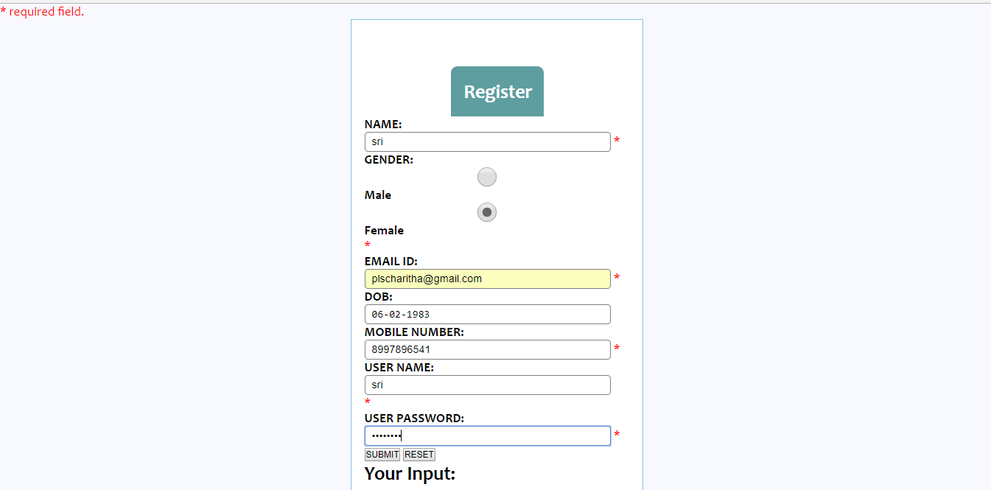



**8. Storing data in MYSQL using PHP**

<?php include('server.php') ?>

<!DOCTYPE html>

<html>

<head>

<title>Registration Form</title>

<link rel="stylesheet" type="text/css" href="style.css">

</head>

<body>

<div class="header">

<h2>Apply Form for funds</h2>

</div>

<form method="POST" action="apply.php">

<div class="input-group">

<label>First Name</label>

<input type="text" name="firstname" required autofocus placeholder="First Name" pattern="[a-zA-Z]{3,}" title="Please enter more than three letters">

</div>

<div class="input-group">

<label>Last Name</label>

<input type="text" name="lastname" required autofocus placeholder="Last Name" pattern="[a-zA-Z]{3,}" title="Please enter more than three letters">

</div>

<div class="input-group">

<label>Email</label>

<input type="text" name="email" required autofocus placeholder="email" pattern="[a-zA-Z0-9]{3,}@{.}{1}[a-zA-Z}{2,}" title="Please enter a valid email id">

</div>

<div class="input-group">

<label>Phone Number</label>

<input type="tel" name="phonenumber" pattern="^\d{10}$" required autofocus placeholder="phonenumber">

</div>

<br>

<label>Gender</label>

<br><br>

<input type="radio" name="gender" value="male" required> Male<br>

<input type="radio" name="gender" value="female" required> Female<br>

<input type="radio" name="gender" value="other" required=""> Other

</div>

<div class="input-group">

<label>Select funds</label><br>

<select name="plan" required>

<option value="" required>Select</option>

<option value="1st class" required>1st class</option>

<option value="medium" required>medium</option>

<option value="high class" required>high class</option>

<option value="ac" required>ac</option>

<option value="Others" required>others</option>

</select>

</div>

<label>Premium Amount</label><br>

<select name="amount" required>

<option value="" required>Select</option>

<option value="1000" required>1000</option>

<option value="2000" required>2000</option>

<option value="3000" required>3000</option>

<option value="4000" required>4000</option>

<option value="5000" required>5000</option>

</select>

<br>

<br>

<input type="checkbox" name="Conditions" value="" required>I agree Terms and Conditions

<div class="input-group">

<pre><button type="submit" name="apply" class="btn">apply</button> <a href="Homepage.htm">Home</a>

</pre>

</div>

</form>

</body>

</html>

**OUTPUT:**

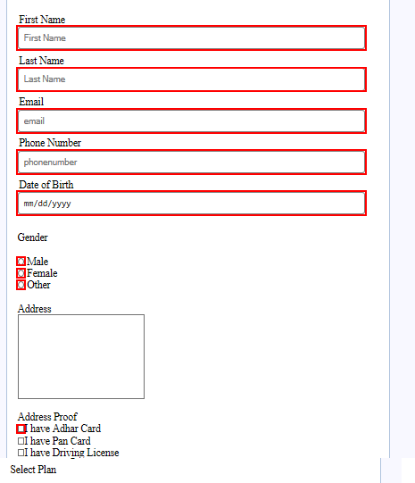

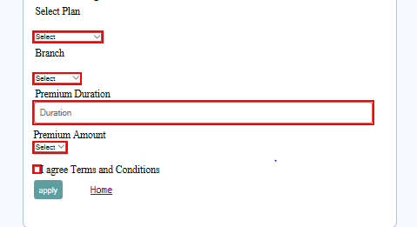

**9. Retrieving data from MYSQL using PHP**

Findpage.html

<?php include('server.php')

?>

<!DOCTYPE html>

<html>

<head>

<title>

search and display</title>

<link rel="stylesheet" type="text/css" href="style.css">

</head>

<div class="header">

<h2>Find the Data</h2>

</div>

<body>

<form action="findpage.php" method="post">

<div class="input-group">

Phone number<input type="number" name="phonenumber" required autofocus placeholder="Search here" pattern="[0-9]{10,}" title="Please enter a valid number">

</div>

<div class="input-group">

<pre><button type="submit" name="search" class="btn">Search</button> <a href="Homepage.htm">Home</a>

</pre></div>

<div class="input-group">

firstname<input type="text" name="firstname" value="<?php echo $firstname;?>">

</div>

<div class="input-group">

Lastname <input type="text" name="lastname" value="<?php echo $lastname;?>">

</div>

<div class="input-group">

Email <input type="text" name="email" value="<?php echo $email;?>">

</div>

<div class="input-group">

Gender <input type="text" name="gender" value="<?php echo $gender;?>">

</div>

<div class="input-group">

Date <input type="text" name="date" value="<?php echo $date;?>">

</div>

<div class="input-group">

Address <input type="text" name="address" value="<?php echo $address;?>">

</div>

<div class="input-group">

Proofs <input type="text" name="proofs" value="<?php echo $proofs;?>">

</div>

<div class="input-group">

Plan <input type="text" name="plan" value="<?php echo $plan;?>">

</div>

<div class="input-group">

Duration <input type="text" name="duration" value="<?php echo $duration;?>">

</div>

<div class="input-group">

Amount <input type="int" name="amount" value="<?php echo $amount;?>">

</div>

</form>

</body>

</html>

**Server.php**

<?php

session_start();

$username="";

$email="";

$phonenumber="";

$errors=array();

$db=mysqli_connect('localhost', 'root', '', 'registration'); if(isset($_POST['search']))

{

$phonenumber=$_POST['phonenumber'];

$connect=mysqli_connect("localhost","root","","registration");

$query="SELECT * FROM `newapply` WHERE `phonenumber`=$phonenumber LIMIT 1";

$result=mysqli_query($connect, $query);

if(mysqli_num_rows($result)>0)

{

while ($row=mysqli_fetch_array($result))

{

$firstname=$row['firstname'];

$lastname=$row['lastname'];

$email=$row['email'];

$gender=$row['gender'];

$date=$row['date'];

$address=$row['address'];

$proofs=$row['proofs'];

$branch=$row['branch'];

$duration=$row['duration'];

$amount=$row['amount'];

}

}

else

{

echo "This number is not available";

$firstname="";

$lastname="";

$email="";

$gender="";

$date="";

$address="";

$proofs="";

$branch="";

$duration="";

$amount="";

}

mysqli_free_result($result);

mysqli_close($connect);

}

else

{

$firstname="";

$lastname="";

$email="";

$gender="";

$date="";

$address="";

$proofs="";

$branch="";

$duration="";

$amount="";

}

?>

**OUTPUT:**

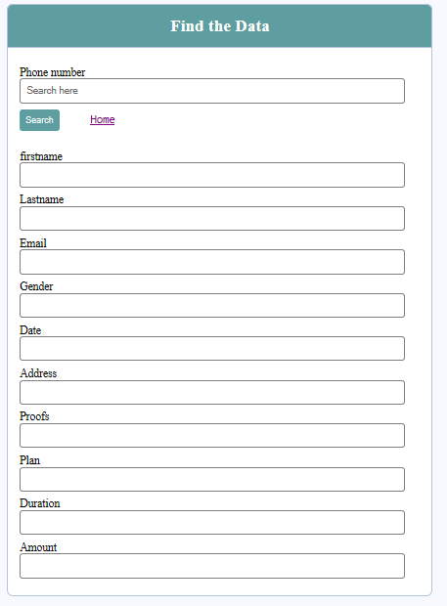

**10. Drill down reports using PHP**

**Code:**

**Index.php**

<?php

$host = "localhost";

$user = "root";

$password = "";

$db = "registration";

$conn = new mysqli($host,$user,$password,$db);

?>

<html>

<head>

<title>Reports in php</title>

<link rel = "stylesheet" type="text/css" href="css/style.css"/>

</head>

<body>

<div class="container">

<div class="wrapper">

<h1>Reports</h1>

</div>

<div class="data">

<form action="index.php" method="POST" >

<select name="branch" required>

<option value="" required>BRANCH</option>

<?php

$query1 = "SELECT * FROM branch";

$result1 = $conn->query($query1);

while($rows1 = mysqli_fetch_array($result1)) //mysqli_fetch_array is used to return an array

{

$sid = $rows1['branch']; //storing the value selected form the displayed lsit

$rowsData1 = $rows1['branch']; //displaying the values from the table

?>

<option value="<?php echo $sid;?>" required><?php echo $rowsData1;?></option>

<?php

}

?>

</select>

<input type="submit" name="submit" class="submit"/> <a href="Homepage.htm">Home</a>

<table border="1" class="table">

<tr>

<th>First Name</th>

<th>Last Name</th>

<th>Phone Number</th>

<th>Premium Amount</th>

<th>Gender</th>

<th>Duration</th>

</tr>

<tr>

<?php

if(isset($_POST['submit'])){

$branchName = $_POST['branch']; //storing the selected value in the php variable

$query3 = "SELECT newapply.firstname, newapply.lastname, newapply.phonenumber, newapply.amount, newapply.gender, newapply.duration FROM newapply WHERE newapply.branch = '$branchName'";

$result3 = $conn->query($query3);

while($rows3 = mysqli_fetch_array($result3)){

$FName = $rows3['firstname'];

$LName = $rows3['lastname'];

$pn=$rows3['phonenumber'];

$amt=$rows3['amount'];

$IGender = $rows3['gender'];

$dr = $rows3['duration'];

?>

<tr>

<td><?php echo $FName; ?></td>

<td><?php echo $LName; ?></td>

<td><?php echo $pn; ?></td>

<td><?php echo $amt; ?></td>

<td><?php echo $IGender; ?></td>

<td><?php echo $dr; ?></td>

</tr>

<?php

}

}

?>

</tr>

</table>

</form>

</div>

</div>

</body>

</html>

**Style.css**

*{

padding: 0px;

margin: 0px;

}

body{

background-color: red;

}

.container{

width: 1300px;

margin: 0 auto;

background-color: #fff;

height: 400px;

margin-top: 10px;

padding: 20px;

}

.wrapper{

margin-bottom: 20px;

}

h1{

font-family: verdana;

color: rgb(84,84,172);

}

.data{

width: 800px;

padding: 10px;

margin-top: 20px;

}

.data select{

width:200px;

padding:3px;

margin: 20px 0px;

float: left;

position: relative;

margin-right: 20px;

}

.submit{

margin-top: 18px;

width: 100px;

padding: 5px;

border: none;

font-weight: bold;

outline: none;

background: blue;

color: white;

cursor: pointer;

}

.table{

margin-top:20px;

border: 1px solid #ccc;

clear: both;

}

.table th{

width:200px;

font-family: verdana;

font-size: 13px;

color: rgb(84,84,172);

padding: 3px 20px 3px 20px;

}

.table td{

text-align: left;

width: 300px;

font-family: verdana;

font-size: 13px;

padding: 3px 68px 3px 68px;

}

**OUTPUT:**

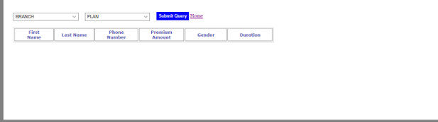

**References:**

[www.w3schools.com](http://www.w3schools.com)

[www.phptutorial.com](http://www.phptutorial.com)

[www.toturials.com](http://www.toturials.com)